leon meeting + bottleneck analysis in coral financing

Leon Boey meeting notes:

Takeaways:
- Duration of sequestered carbon storage relative to deforestation and other means of carbon capture is unknown
- His current understanding is investors just want a simple carbon value

- How long does coral store carbon? This hasn’t been addressed yet.
  - One next step now that they have information about sequestration
    - Continuing research
- Focus on carbon first because that’s what investors value
- Coral on a clothesline, bring it up every month
  - Simple methodology
  - 6m long pole
- Corporate sponsors say they need to see carbon emission amounts
- Investors ask for carbon measurements but then don’t say much about it, not necessarily knowledgeable
  - 1sqm = 5kg (4.4 - 6.6kg) coral restoration = 1 star = $65
    - $13/kg
      - Expensive compared to trees
  - Now that the numbers from the research are available, he shares them with investors
  - Coral restoration offers long timeline compared to reforestation (e.g. reforestation nonprofits or local communities often chop down trees after replanting —> solicit more donations —> replant) vs coral has multiplicative carbon sequestration effect
    - Benefit is typically measured in tonnage without account for timelines
    - Long time in water = multiplicative growth
  - Controversy with destroyed reefs
  - Carbon locked underwater more damaging than carbon trapped in the air
- Investor interaction
  - Private investors - moved by stories/trust in Leon’s experience and character
  - Corporations - moved by numbers / tonnage
  - Impact loans - looking into, trying to secure
    - TUI care foundation - proof of concept is done, they know we can be a sustainable investment but looking for lenders
  - Direct impact/sponsorship - mostly to make themselves look good
- Verra
  - No plan for marine methodology
  - Strict standards, specific
- Science team measuring everything
- Still interested in carbon credit market?
  - Coral is a sink vs source
  - Turns carbon dioxide from the water into carbonate, changing the alkalinity of the water and making it less able to absorb carbon from the error —> source, doesn’t actually return
    - This is a difficult argument to overcome - sink or source —> hard to enter into carbon markets, but might go into biodiversity credits
    - Verra has 30/40 methodologies to measure
    - Reached out to Verra via email, had a meeting with them - no plan to develop due to alkalinity problem - source not sink
- Most valuable possible project outcome = understand what investors value
  - Straightforward if they care exclusively about carbon capture
  - What else should the researchers look at?
  - Is something like economic benefit or fish biomass of interest to them?

1. Framing
Last week’s deliverable mapped six hybrid valuation models across scope, metrics, pricing logic, monitoring, and implications. This week builds on that foundation by analyzing why these models fail to scale in marine finance. The analysis draws on three dimensions:
- Technical bottlenecks – measurement, monitoring, and methodological uncertainty
- Economic bottlenecks – pricing, cost competitiveness, and investor demand
- Institutional bottlenecks – governance, certification, and replicability
Insights from my call with Leon Boey (Livingseas Asia/Foundation) are integrated to ground this analysis in real-world friction rather than theory.

2. Bottleneck Analysis by Dimension

A. Technical Bottlenecks
- Carbon measurement uncertainty:
  - Coral sequestration is measurable (4.4–6.6 kg CO₂/m²/year), but questions remain about how long carbon is stored and whether reefs are net sinks or sources due to alkalinity shifts.
  - Monitoring methods (e.g., “coral on a clothesline,” monthly weighing, photo documentation) are simple and replicable, but lack the precision of forestry MRV.
- Comparability across sites:
  - Reef growth rates vary by species, depth, and disturbance history.
  - Unlike mangroves or forests, there is no standardized global baseline for reef carbon.
- Hybrid metrics complexity:
  - Models like GFCR and BNCFF track multiple indicators (reef health, livelihoods, ROI), but the lack of harmonization makes aggregation difficult.
  - GFCR - Global Fund for Coral Reefs
    - Has developed a Monitoring & Evaluation (M&E) Framework aligned with its Theory of Change, but each funded program is expected to develop its own program-specific M&E plan, even though they’re encouraged to align with GFCR’s core indicators.
    - GFCR uses platforms like MERMAID and ReefCloud, but implementation varies by project — some use AI-based benthic analysis, others rely on manual diver surveys.
    - UNEP (United Nations Environment Programme) is actively working to coordinate GFCR M&E strategies with global initiatives (e.g., Global Biodiversity Framework), but this is still in progress
    - Implication: While GFCR provides a toolkit, the execution is decentralized — meaning coral cover, fish biomass, or livelihood metrics may be defined and measured differently across projects. This makes aggregation and cross-project comparison difficult.
  - Blue Natural Capital Financing Facility (BNCFF)
    - BNCFF supports early-stage blue nature-based solutions (NbS) projects, but: Projects report ecosystem service values (e.g., carbon, fisheries, tourism) using project-specific valuation methods, not a unified protocol.
    - Monitoring and evaluation is tailored to each project’s context, with no standardized reef-specific MRV schema (Measurement, Reporting, and Verification).
    - A midterm evaluation is underway to assess delivery consistency and recommend course corrections.
    - Implication: BNCFF helps build investment cases, but the lack of a common measurement framework means each project defines its own metrics — useful for local impact, but hard to roll up into a portfolio-level reef valuation
  - Reaching investors for these two funds:
    - GFCR operates both a Grant Fund and an Investment Fund, targeting blended finance. It engages impact investors, development banks, and philanthropic capital through its Secretariat and partners like UNEP.
    - GFCR is backed by UNDP, UNEP, UNCDF, Germany, BNP Paribas, Pegasus Capital Advisors, and philanthropic foundations. These institutions bring their own investor networks.
    - Both GFCR and BNCFF host or join global events (UNGA, COP, Our Ocean Conference) to pitch reef-positive pipelines.
    - Accelerators and matchmaking: GFCR runs the REEF+ Accelerator to incubate reef-positive businesses and connect them with capital. BNCFF provides project prep grants and showcases “bankable” projects to private investors.
    - Direct deal flow: Local NGOs or enterprises apply for support; the fund vets them, then introduces them to aligned investors.
  - How investors find them: Impact investors and ESG-focused corporates look for new asset classes aligned with SDG14 (United Nations Sustainable Development Goal focused on blue sustainability). Development banks (e.g., ADB, World Bank) scan for blended finance opportunities where concessional capital can crowd in private money.
  - What investors purchase:
    - Investors are not buying “coral credits” (yet). Instead, they are purchasing financial exposure to reef-positive activities through a blended portfolio including:
      - Equity stakes in reef-positive enterprises (e.g., sustainable aquaculture, eco-tourism, reef insurance products).
      - Debt instruments (concessional loans, impact bonds) where repayment is linked to enterprise revenue.
      - Outcome-based contracts (rare, but emerging) where repayment is tied to verified ecological or social outcomes.
  - Investment flow diagram:
    - 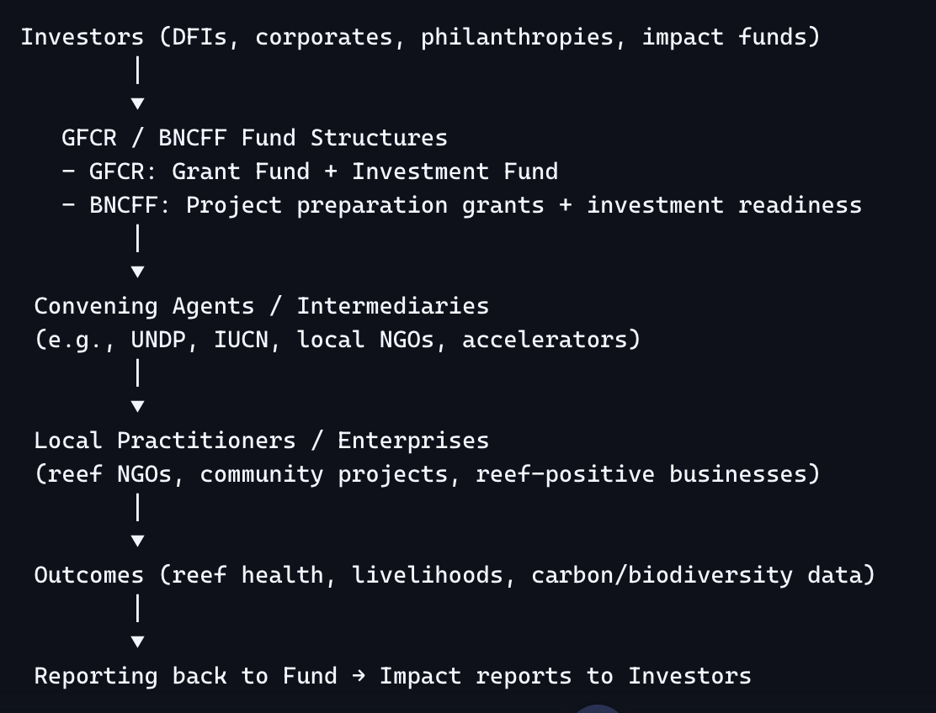

1. GFCR vs. BNCFF — Comparison Table
Feature | GFCR (Global Fund for Coral Reefs) | BNCFF (Blue Natural Capital Financing Facility)
Structure | Dual vehicle: (1) Grant Fund (UN MPTF) for NGOs, communities, enabling conditions; (2) Investment Fund (managed by Pegasus Capital Advisors) for reef‑positive enterprises | Facility managed by IUCN, funded by Luxembourg & UBS Optimus Foundation; provides project preparation grants and technical assistance
Investor Role | Investors commit to the fund, not individual projects. GFCR allocates capital via convening agents (UNDP, UNEP, UNCDF). | Donors/investors fund the facility; IUCN screens and selects projects for support.
What Investors Buy | • In the Investment Fund: equity/debt in reef‑positive businesses (sustainable aquaculture, eco‑tourism, reef insurance).  • In the Grant Fund: catalytic grants (no financial return). | • Grants for early‑stage project prep (no direct financial return).  • Goal is to make projects “investment‑ready” for future private capital.
Return Expectation | • Investment Fund: modest financial return (blended finance, concessional).  • Grant Fund: impact return only. | • No financial return; “return” is pipeline of investable projects and ecosystem outcomes.
Risk Allocation | Portfolio approach spreads risk across multiple projects. Grants de‑risk investments for private capital. | Grants absorb early risk; projects may later attract private investors once bankable.
Practitioner Access | NGOs, nonprofits, and community groups can apply for grant funding. Enterprises can access investment capital. | Nonprofits and NGOs can apply for technical assistance and prep grants to build business cases.
Investor Differentiation vs. Donation | • Portfolio diversification  • Structured reporting on ecological & social outcomes  • Potential financial return (Investment Fund) | • Structured vetting by IUCN  • Pipeline creation for future investment  • Impact reporting to donors

Takeaway: Technical progress is being made (Livingseas’ field-based methods), but without consensus on sink vs. source status, reefs remain excluded from mainstream carbon markets.

B. Economic Bottlenecks
- Cost competitiveness:
  - Livingseas estimates ~$13/kg CO₂ for coral restoration vs. <$10/ton for forestry offsets → reefs appear “expensive” when compared purely on carbon price.
- Investor psychology:
  - Corporates ask for carbon numbers but often lack the expertise to interpret them.
  - Private investors are swayed more by trust and narrative than by tonnage.
  - Impact lenders (e.g., TUI Care Foundation) want proof of concept and repayment pathways.
- Timeline mismatch:
  - Coral offers multiplicative growth over decades, but investors typically value short-term tonnage.
  - Forestry faces “chop and replant” cycles, while reefs, once established, can persist — but this long-term advantage is not priced in.
Takeaway: The economic bottleneck is not just cost, but the mismatch between reef value timelines and investor valuation horizons.

C. Institutional Bottlenecks
- Certification gap:
  - Verra has no methodology for coral due to the alkalinity “sink vs. source” debate.
  - Plan Vivo and others are carbon-centric; reef-specific methodologies don’t exist.
- Governance models:
  - Blue Abadi and SeyCCAT show strong governance, but their structures are tied to sovereign or trust contexts, limiting replicability.
- Fragmented accountability:
  - As noted in BUAD493 fieldwork, NGOs, governments, and tourism operators operate in silos, with little coordination on valuation standards.
Takeaway: Without a certifier-approved methodology, even the best field data cannot translate into credits. Institutional inertia is as much a barrier as technical uncertainty.

3. Synthesis: Why Hybrid Models Fail to Scale
- Technical: Lack of standardized, credible MRV for reefs → uncertainty.
- Economic: High cost per ton + long timelines → unattractive compared to forestry.
- Institutional: No certifier methodology + fragmented governance → no pathway to credits.
Hybrid models succeed in local impact (community benefits, biodiversity, governance) but fail in scalability because they cannot bridge these three bottlenecks simultaneously.

4. Insights from Leon Boey (Livingseas)
- Carbon-first strategy: Investors demand carbon numbers, even if they don’t fully understand them.
- Simple, replicable methods: Livingseas’ low-tech monitoring (monthly weighing, photo documentation) could democratize reef MRV.
- Investor segmentation:
  - Corporates → want tonnage, even if superficial.
  - Private investors → trust and narrative.
  - Lenders → proof of concept and repayment.
- Market reality: Coral carbon is expensive vs. trees, but offers durability and multiplicative growth.
- Certification deadlock: Verra uninterested due to sink/source controversy; biodiversity credits may be more viable.

5. Next Steps for Research
- Investor psychology deep dive: Interview ESG investors to test whether they value only carbon or if biodiversity, fish biomass, or economic co-benefits resonate.
- Comparative pricing analysis: Benchmark coral vs. forestry vs. mangroves to highlight where reefs are disadvantaged and where they offer unique value.
- Framework design: Explore a hybrid reef credit that combines carbon + biodiversity + community benefits, sidestepping the sink/source controversy.
- Institutional mapping: Identify which certifiers or coalitions (e.g., Plan Vivo, ICRI, UNEP) might be open to piloting reef methodologies.

